We will be having a field day August 12, 2016 about Gypsum. The following day we will be hosting Michigan L.I.C.A. Field day August 13, 2016. We request that you RSVP so we will know how many will be attending and how many will need an overnight camp space. Lunch will be provided. Please feel free to bring a soil sample so we can discuss your soil. More Information is to come. You can also fax or email in your RSVP to 517-726-1448 or 989-867-4483, and limeandgypsumsales@gmail.com or limeandgypsumnorth@gmail.com .

- Will you be attending? YES NO
- How many will be attending? _______
- Will you be Staying overnight at our camp space? Yes No
- Is there a certain Topic you would like to be discussed? _______________________
__________________________________________________________________________________________________________________________________________________________________
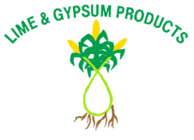
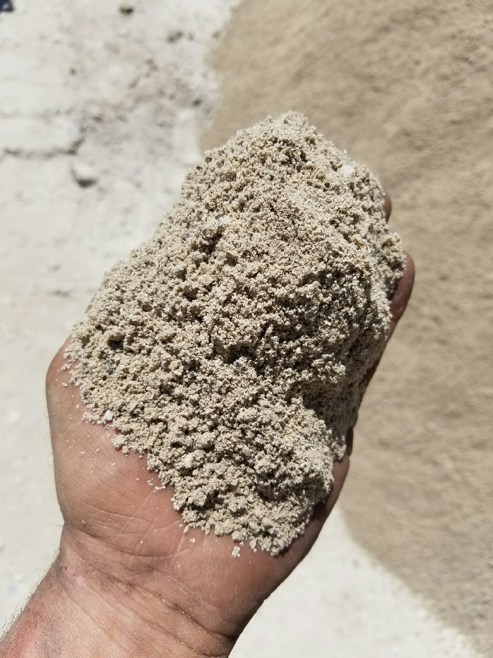
R.S.V.P.
2016 Field Day
“Let’s Talk Gypsum”

